Lab – 10

Q1.

## views.py:

from django.shortcuts import render from .forms import BookForm

def book_view(request):

form = BookForm(request.POST or None) if form.is_valid():

form.save()

return render(request, 'books/book_form.html', {'form': form})

## books/urls.py :

from django.urls import path from .views import book_view

from django.views.generic import RedirectView from django.urls import reverse_lazy

urlpatterns = [

path('', RedirectView.as_view(url=reverse_lazy('add-book'))), path('add-book/', book_view, name='add-book'),

]

## library_project/urls.py :

from django.contrib import admin from django.urls import path from django.urls import include

urlpatterns = [

path('', include('books.urls')), path('admin/', admin.site.urls),

]

**forms.py:**

from django import forms

from .models import Book, Author, Publisher

class BookForm(forms.ModelForm): class Meta:

model = Book fields = ' all ' widgets = {

'publication_date': forms.DateInput(attrs={'type': 'date'}), 'authors': forms.SelectMultiple(attrs={'size': 5}), 'publisher': forms.Select()

}

## models.py:

from django.db import models

class Author(models.Model):

first_name = models.CharField(max_length=100) last_name = models.CharField(max_length=100) email = models.EmailField()

def str (self):

return f"{self.first_name} {self.last_name}"

class Publisher(models.Model):

name = models.CharField(max_length=200) street_address = models.CharField(max_length=200) city = models.CharField(max_length=100) state_province = models.CharField(max_length=100) country = models.CharField(max_length=100) website = models.URLField()

def str (self): return self.name

class Book(models.Model):

title = models.CharField(max_length=200) publication_date = models.DateField() authors = models.ManyToManyField(Author)

publisher = models.ForeignKey(Publisher, on_delete=models.CASCADE)

def str (self): return self.title

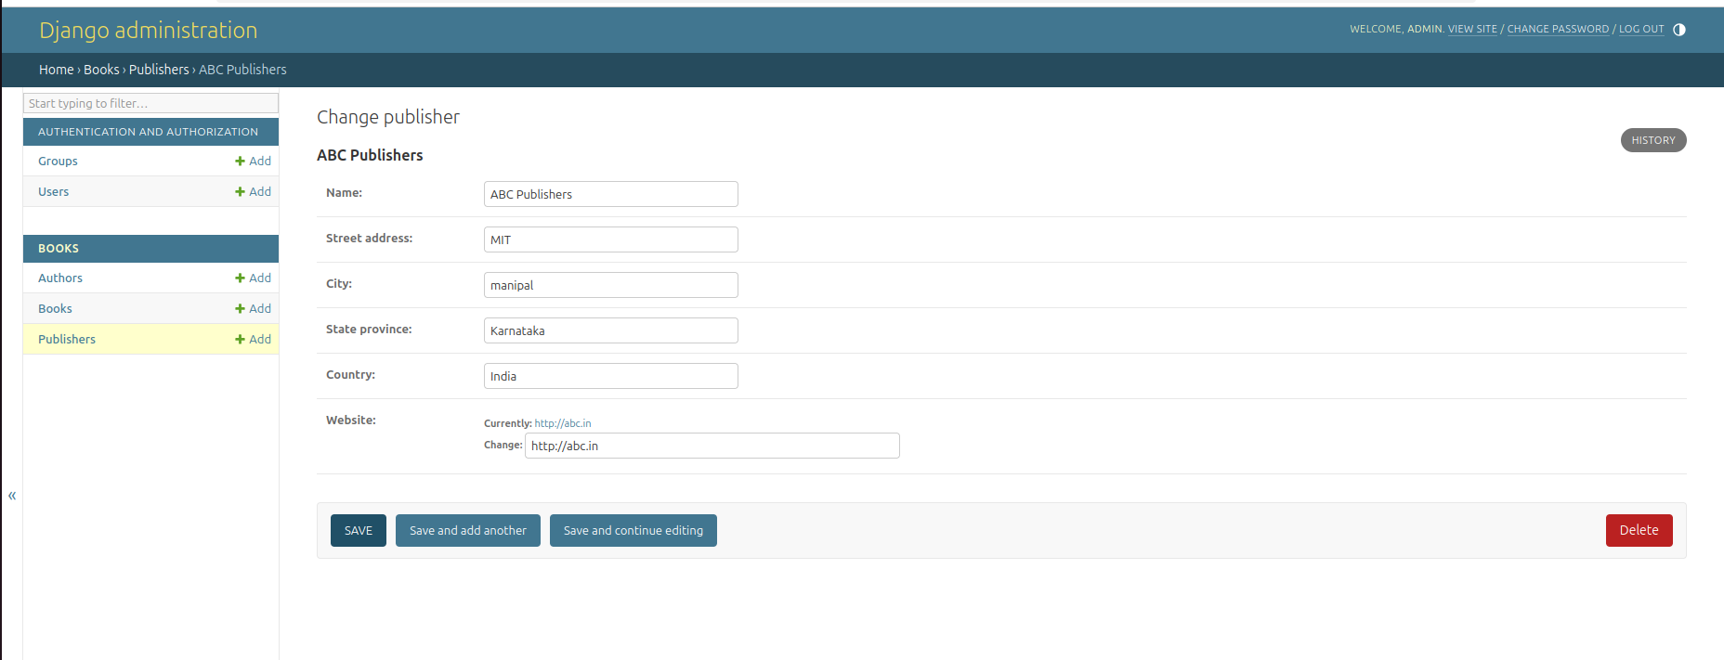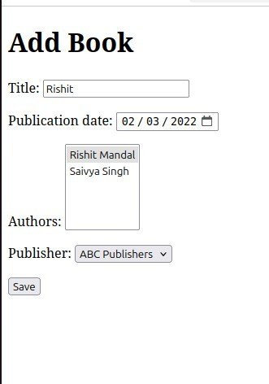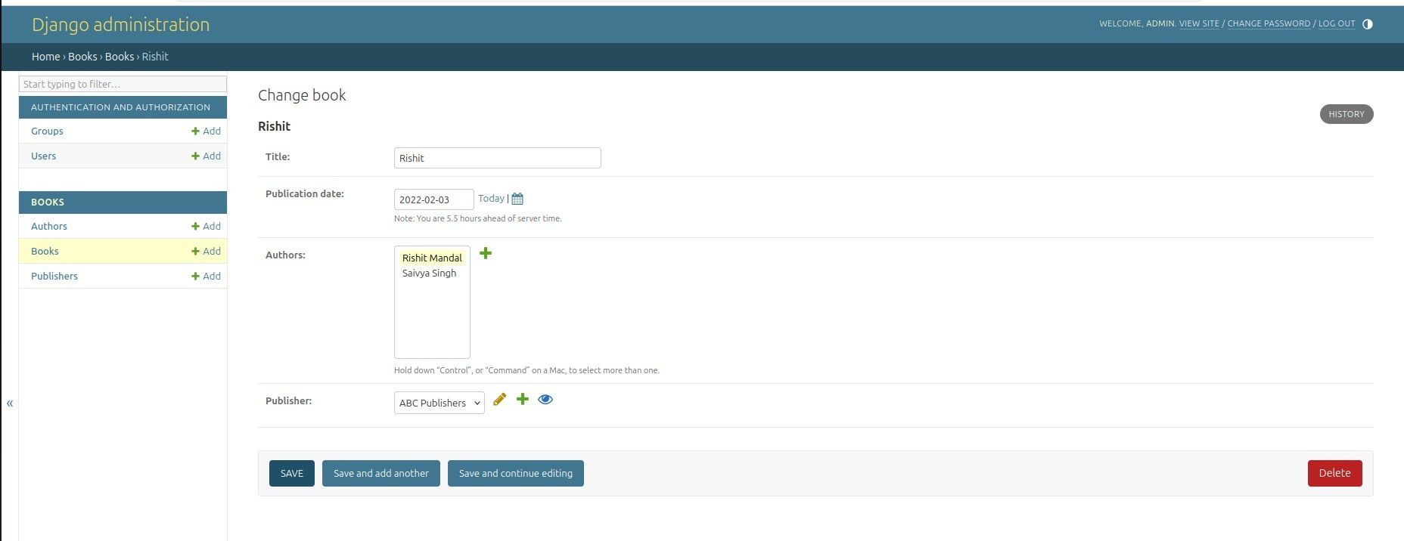

## Q2.

**views.py**

from django.shortcuts import render, redirect from .models import Product

from .forms import ProductForm

def product_list(request):

products = Product.objects.all()

return render(request, 'product_list.html', {'products': products})

def add_product(request):

if request.method == 'POST':

form = ProductForm(request.POST) if form.is_valid():

form.save()

return redirect('product_list') else:

form = ProductForm()

return render(request, 'add_product.html', {'form': form})

## urls.py

from django.urls import path

from .views import product_list, add_product

urlpatterns = [

path('', product_list, name='product_list'), path('add/', add_product, name='add_product'),

]

## product_list.html

<!DOCTYPE html>  
<html lang="en">

<head>

<meta charset="UTF-8">

<meta name="viewport" content="width=device-width, initial-scale=1">

<title>Product List</title>

<!-- Bootstrap CSS -->

<link hr[ef="https://cdn.jsdelivr.net/npm/bootstrap@5.3.0/dist/css/bootstrap.min.css"](https://cdn.jsdelivr.net/npm/bootstrap%405.3.0/dist/css/bootstrap.min.css) rel="stylesheet">

</head>

<body class="bg-light">

<div class="container mt-5">

<h1 class="text-center mb-4">Products List</h1>

<ul class="list-group">

{% for product in products %}

<li class="list-group-item">

<h5 class="fw-bold">{{ product.title }}</h5>

<p class="text-muted">Price: Rs. {{ product.price }}</p>

<p>{{ product.description }}</p>

</li>

{% endfor %}

</ul>

<div class="text-center mt-4">

<a href="{% url 'add_product' %}" class="btn btn-primary">Add New Product</a>

</div>

</div>

<!-- Bootstrap JS -->

<script src[="https://cdn.jsdelivr.net/npm/bootstrap@5.3.0/dist/js/bootstrap.bundle.min.js">](https://cdn.jsdelivr.net/npm/bootstrap%405.3.0/dist/js/bootstrap.bundle.min.js)</ script>

</body>

</html>

## add_product.html

<!DOCTYPE html>

<html lang="en">

<head>

<meta charset="UTF-8">

<meta name="viewport" content="width=device-width, initial-scale=1">

<title>Add Product</title>

<!-- Bootstrap CSS -->  
<link hr[ef="https://cdn.jsdelivr.net/npm/bootstrap@5.3.0/dist/css/bootstrap.min.css"](https://cdn.jsdelivr.net/npm/bootstrap%405.3.0/dist/css/bootstrap.min.css) rel="stylesheet">

</head>

<body class="bg-light">

<div class="container mt-5">

<h1 class="text-center mb-4">Add a New Product</h1>

<div class="card shadow-sm p-4">

<form method="post">

{% csrf_token %}

<div class="mb-3">

<label class="form-label">Title</label>

{{ form.title }}

</div>

<div class="mb-3">

<label class="form-label">Price</label>

{{ form.price }}

</div>

<div class="mb-3">

<label class="form-label">Description</label>

{{ form.description }}

</div>

<button type="submit" class="btn btn-success">Save Product</button>

</form>

</div>

<div class="text-center mt-4">

<a href="{% url 'product_list' %}" class="btn btn-secondary">Back to Product List</a>

</div>

</div>

<!-- Bootstrap JS -->

<script src[="https://cdn.jsdelivr.net/npm/bootstrap@5.3.0/dist/js/bootstrap.bundle.min.js">](https://cdn.jsdelivr.net/npm/bootstrap%405.3.0/dist/js/bootstrap.bundle.min.js)</ script>

</body>

</html>

## models.py

from django.db import models

class Product(models.Model):

title = models.CharField(max_length=200)

price = models.DecimalField(max_digits=10, decimal_places=2) description = models.TextField()

def str (self): return self.title

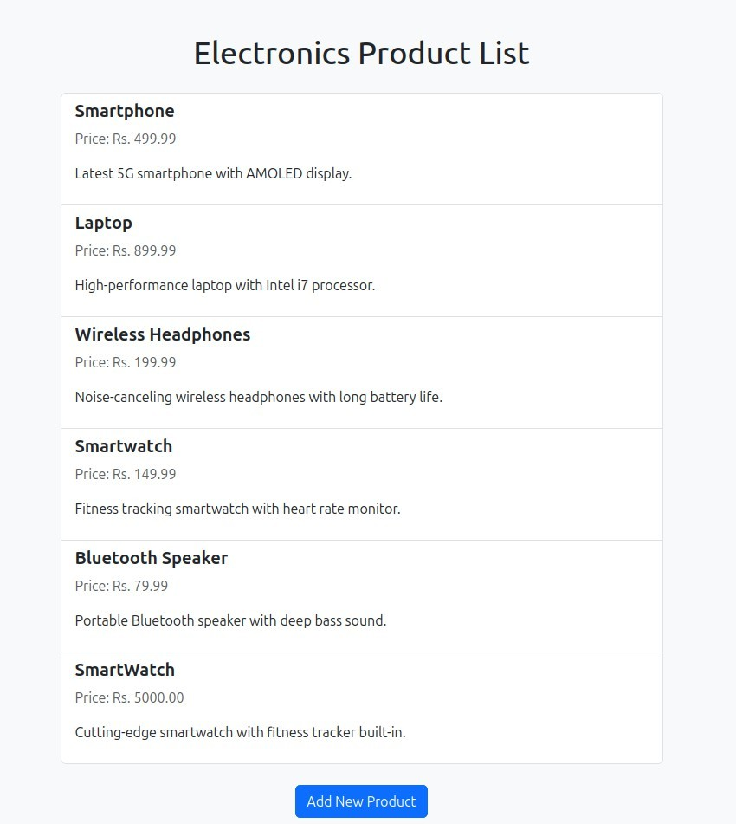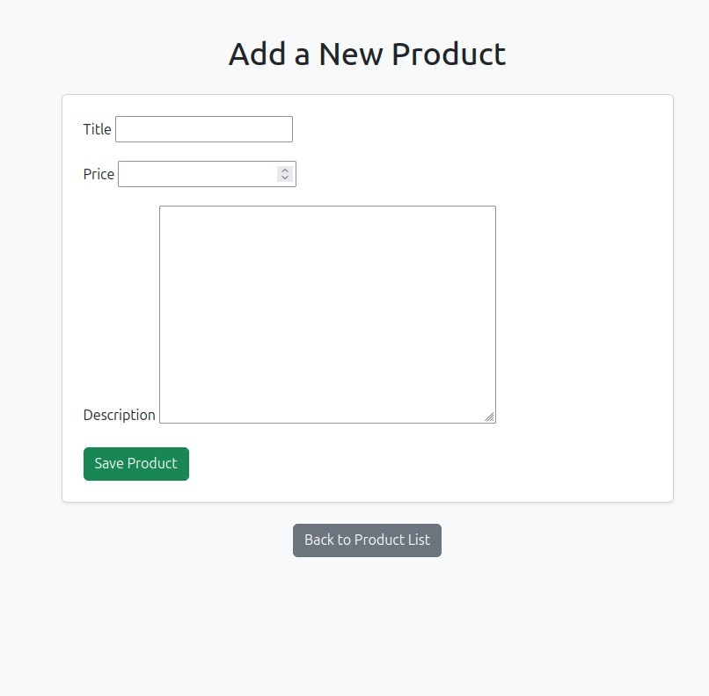

Q3.

### views.py

from django.shortcuts import render, get_object_or_404 from django.http import JsonResponse

from .models import Human from .forms import HumanForm

def index(request):

humans = Human.objects.all() form = HumanForm()

return render(request, 'people/index.html', {'humans': humans, 'form': form})

def get_human(request):

if request.method == 'GET': id = request.GET.get('id')

human = get_object_or_404(Human, id=id) return JsonResponse({

'last_name': human.last_name, 'phone': human.phone, 'address': human.address, 'city': human.city,

})

def update_human(request):

if request.method == 'POST': id = request.POST.get('id')

human = get_object_or_404(Human, id=id)

form = HumanForm(request.POST, instance=human) if form.is_valid():

form.save()

return JsonResponse({'status': 'updated'})

def delete_human(request):

if request.method == 'POST':

id = request.POST.get('id')

human = get_object_or_404(Human, id=id) human.delete()

return JsonResponse({'status': 'deleted'})

### model.py

from django.db import models

class Human(models.Model):

first_name = models.CharField(max_length=100) last_name = models.CharField(max_length=100) phone = models.CharField(max_length=20) address = models.CharField(max_length=200) city = models.CharField(max_length=100)

def str (self):

return self.first_name

### urls.py

from django.urls import path from . import views

urlpatterns = [

path('', views.index, name='index'),

path('get-human/', views.get_human, name='get_human'), path('update-human/', views.update_human, name='update_human'), path('delete-human/', views.delete_human, name='delete_human'),

]

### index.html

<!DOCTYPE html>

<html>

<head>

<title>Human CRUD</title>

<script>

function loadData() {

const id = document.getElementById("human-select").value; fetch("/get-human/?id=" + id)

.then(res => res.json())

.then(data => {

});

}

document.getElementById("id").value = id; document.getElementById("id_last_name").value = data.last_name; document.getElementById("id_phone").value = data.phone; document.getElementById("id_address").value = data.address; document.getElementById("id_city").value = data.city;

function updateData() {

const form = document.getElementById("human-form"); const formData = new FormData(form);

fetch("/update-human/", { method: "POST",

headers: {'X-CSRFToken': getCookie("csrftoken")}, body: formData

})

.then(res => res.json())

.then(data => location.reload());

}

function deleteData() {

const formData = new FormData();

formData.append("id", document.getElementById("id").value); fetch("/delete-human/", {

method: "POST",

headers: {'X-CSRFToken': getCookie("csrftoken")}, body: formData

})

.then(res => res.json())

.then(data => location.reload());

}

function getCookie(name) { let cookieValue = null;

if (document.cookie && document.cookie !== '') { const cookies = document.cookie.split(';');

for (let cookie of cookies) { cookie = cookie.trim();

if (cookie.startsWith(name + '=')) {

cookieValue = decodeURIComponent(cookie.slice(name.length + 1)); break;

}

}

}

return cookieValue;

}

</script>

</head>

<body>

<h1>Human Info</h1>

<label>First Name:</label>

<select id="human-select" onchange="loadData()">

<option disabled selected>Select a person</option>

{% for h in humans %}

<option value="{{ h.id }}">{{ h.first_name }}</option>

{% endfor %}

</select>

<form id="human-form">

<input type="hidden" name="id" id="id">

{{ form.as_p }}

</form>

<button onclick="updateData()">Update</button>

<button onclick="deleteData()">Delete</button>

</body>

</html>

### forms.py

from django import forms from .models import Human

class HumanForm(forms.ModelForm): class Meta:

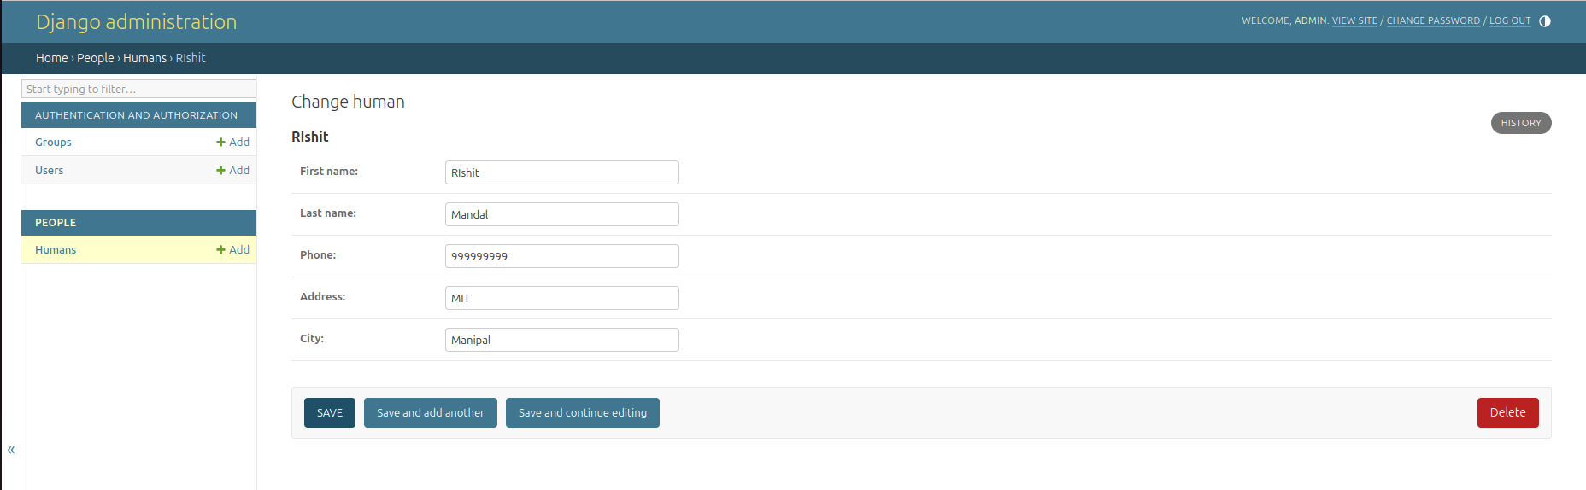model = Human fields = ' all '

